**Mission 5:**

**Remix**

**Student Workbook**





**Mix it up with sound!**

This assignment will let you be creative and come up with your own program for the   
CodeX to run.



Go to the Mission 5 Remix Log and fill out the Pre-Remix preparation.



**Time for a project remix**

A remix can be:

* A new program created by adding new code to a program you already created
* You can combine parts of two or more programs in a remix
* Use a similar idea in a different way

**Creating a remix will let you:**

* Master the skills and concepts practiced in the mission
* Be creative
* Remember code from earlier programs and missions
* Work with your peers
* Design an original program and write the code all on your own

**Step #1: Review the mission**

* Review your programs from Mission 2 through 5
  + What do the programs do?
  + What skills were used or concepts learned?

**DO THIS:**

* Open your project from Mission 5 - Music1
* Review what the program does
* Review the programming concepts and skills you learned
* Fill out the information in the remix log

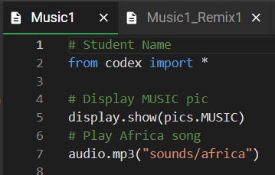

**Step #2: Brainstorm ideas**

* Read through remix suggestions
  + Six ideas are on the next pages. You can use any of these ideas or come up with your own.
* Use your creativity to come up with your own idea for a project
* Decide with your partner what project you will do



**Mild Remix #1A**

Add a voice prompt for the game created in Mission 4 (Display). Either replace each display.print() and audibly prompt the user which button must be pressed, or include both the display and the audio.

[Video of Remix #1A](https://youtu.be/eNSe4EQKaz8)



**Mild Remix #1B**

Open the Mission 4 program (Display). Add an audio file to the if statements to indicate correct or wrong. You can use “okay” and “no” or any of the audio files.

[Video of Remix #1B](https://youtu.be/C_zgr9d5u_8)

**Medium Remix #2A**

Combine the two mild remixes into one program -- use an audio prompt for the button to press and an audio file for correct or wrong. Also, add print statements at the beginning for an intro and a print statement at the end.

[Video of Remix #2A](https://youtu.be/7BKX4gG7K7Y)



**Medium Remix #2B**

Create turn signals for a bicycle. Press button L to turn left, button R to turn right. Blink to pixels to indicate the turn, and use an audio file to say the direction you are turning.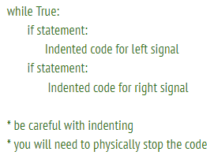

EXTENSION: use a while True: loop to use the turn signals more than once.

[Video of Remix #2B](https://youtu.be/7aEgEoBGnoA) [Video of Remix #2B with Extension](https://youtu.be/4U4r-5LklMI)



**Spicy Remix #3A**

Program each button to do a different task. For example, BTN_A could light pixels and display an image. BTN_B could display an image and play audio. BTN_U could cause pixels to blink random colors. And so forth. Make sure to use at least two audio clips.

[Video of Remix #3A](https://youtu.be/j9zlExVtE0w)



**Spicy Remix #3B**

Program at least three buttons to display a short poem and play an audio file.

[Video of Remix #3B](https://youtu.be/7ttJutyHie8)

**DO THIS:**

* Decide with your partner what project you   
   will do
* Fill out the information in the Mission 5 Remix   
   Log for **Step #2**

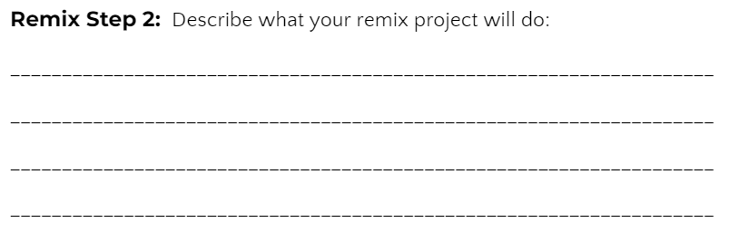

**Step #3: Make a plan**

Now that you have an idea for your remix, you need a plan.

* What variables will you need?
  + NOTE: You do not have to use a variable for this remix
* What colors will you use?
* What images will you display?



**DO THIS:**

* Fill out the information in the Mission 5 Remix Log for **Step #3**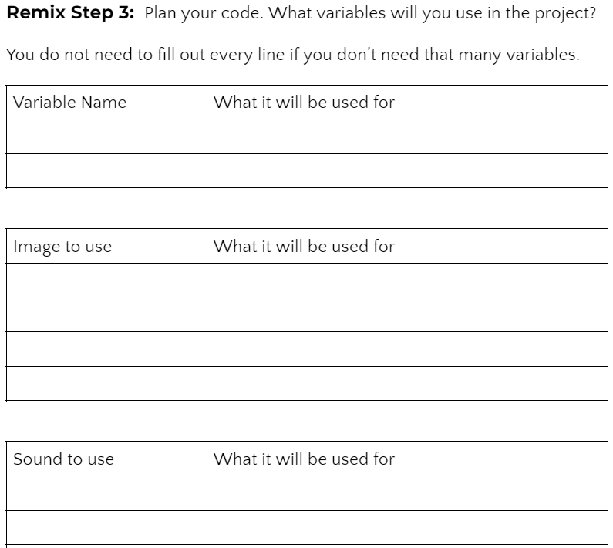

**Step #4: Code your project**

* **IMPORTANT:** In CodeSpace, go to the sandbox:  It is above the toolbox in the lower left corner.
* You can leave your projects open as a guide: **Display, Music1, Pixel1**, remix projects, etc.



**DO THIS:**

* Start with a new file and give it a descriptive   
   name (**Remix5**)
* Import your modules
* Define your variables
* Write your code, testing frequently

**Reminders!**

* Don’t try to write all the code at one time
* Mistakes happen, so find them early
* Type just a few lines of code and then run the program
* If there is an error, fix it before continuing
* Use the debugger and your other programs for help

**Step #5: Documentation**

You should always make your code readable and easy to follow.



**DO THIS:**

* + - * Add blank lines where needed to divide sections of code
      * Add a comment at the top with your name and the name of the program
      * Add a few more comments to sections of your code that explain what they do

**Step #5: Get feedback**

Getting feedback and reflecting on your code can help you make the program even better.



**DO THIS:**

* Show your code to another student
* Have him/her fill out the feedback form on your   
  Mission 5 Remix Log
* Give yourself some feedback
* Is there something you want to change or   
  improve or add?
* Fill out the feedback form on your Mission 5   
  Remix Log

**Modify your code to make your project even better**

**Congratulations!**

Now you have your own remix!   
Great job! Share your project with   
your friends.

By completing this remix you have:

* learned more about programming
* used skills and concepts from the missions
* been thinking!
* and problem solving
* and much more!
* 

**DO THIS:**

* Complete the Mission 5 Remix Log
* Don’t forget to clear your CodeX by   
   running your **Clear** program